Name:______________________ Units: __________ Date: ___________
Math 6th Study Guide: Unit 11 Data Displays

Directions: Carefully read and follow the directions for each section. Remember to SHOW YOUR WORK and write your answers on the lines provided.
1.) Use the histogram that shows the test scores by students in a class to answer the following questions:
1a.) Which interval contains no
data values? ____________

1b.) How many students are in the class? ______

1c.) How many students got a score below 61%?
___________

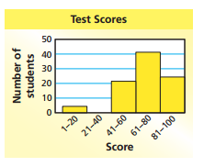
2.) Use the data from the table to draw a histogram below
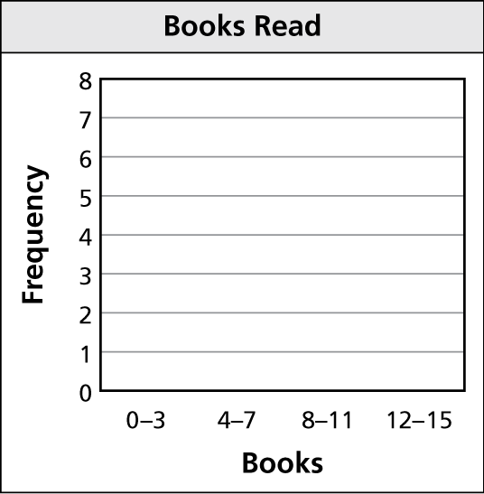
States Visited
States Visited
States | Frequency
1-5 | 12
6-10 | 14
11-15 | 6
16-20 | 3

16
14
12
10
8
6
4
2
0

1-5 6-10 11-15 16-20
States

3.) Choose one of these ways to describe each data display below. You may use a word more than once.
skewed right, skewed left or symmetric
3a.) 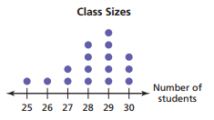 3a.) ________________

3b.) 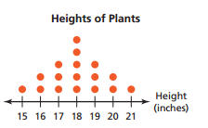 3b.) ________________

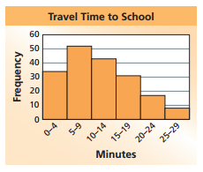

3c.) 3c.) ________________
4.) The box-and-whisker plot shows the ages (in years) of spider monkeys at a zoo. Match the parts of the graph to the words below.
Word bank:
First Quartile Greatest Value Least Value Median Third Quartile

b
c
d
e
a

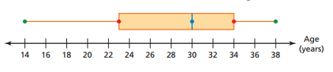

Write the correct word on the line:

4a.)_______________ 4b.)_______________ 4c.)_______________

4d.)_______________ 4e.)_______________

5.) This box-and-whiskers plot shows the running time (in minutes) of movies being shown at a theater. Answer the questions below based on the graph.

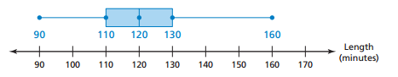
5a.) What is the median running time of a movie? 5a.)______________

5b.) Is the data more spread out below the first quartile or
above the third quartile? 5b.) _______________

5c.) What percent of the movies have a running time of at least 130 minutes?

5c.)_____________

6.) The data shows the ages of teachers (in years) who teach sixth grade.
30, 62, 26, 35, 45, 22, 49, 32, 28, 50, 42, 35
6a.) Make a box-and-whisker plot of the data.

6b.) Find the range and interquartile range.
Range = _____________
Interquartile Range = _____________
6c.) Identify the shape of the distribution. Explain.

